Rodrigo Becerril Ferreyra
Professor Gevik Sardarbegians
CECS 440 Section 02
09 November 2021
Lab 5
The purpose of Lab 5 is to simulate a very basic processor. This processor takes 16-bit instructions, performs calculations, and saves the result in the specified address. The register is a 16-bit 16-wide memory block that has a few differences from your average load register: it includes build-in asynchronous read outputs that read values from specified addresses in the register. Also, on reset, all values inside the memory are initialized to 0 except the value inside address 1, which is initialized to 1. Lastly, addresses 0 and 1 are untouchable: any attempted writes to these addresses fail, and their values are always 0 and 1, respectively. A video demonstration of this lab can be found here: https://youtu.be/EIHFrSmEKOs.
Here is the waveform of the simulation as seen in the video:
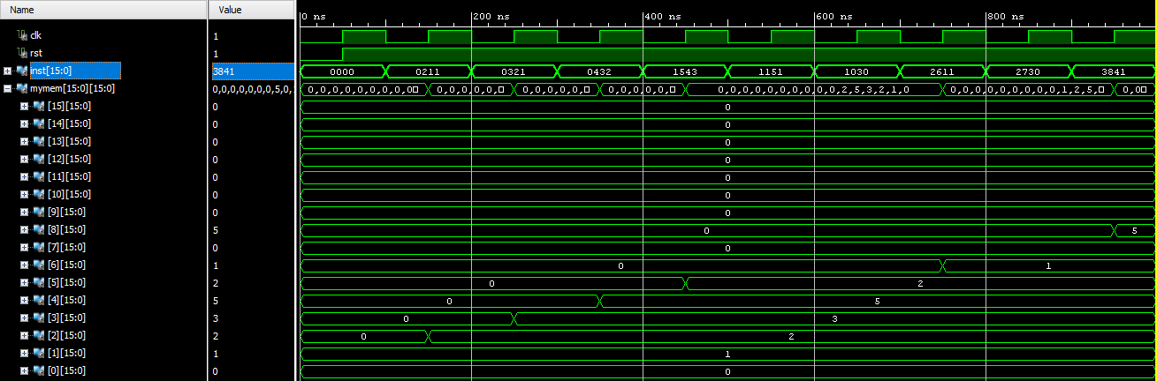
Below is a table as requested in the Lab description detailing the results of all the instructions requested:
Instruction | op | rd | rs | rt | Value in rd
ADD R2, R1, R0 | 0x0 | 0x2 | 0x1 | 0x0 | 2
ADD R3, R2, R1 | 0x0 | 0x3 | 0x2 | 0x1 | 3
ADD R4, R3, R2 | 0x0 | 0x4 | 0x3 | 0x2 | 5
SUB R5, R4, R3 | 0x1 | 0x5 | 0x4 | 0x3 | 2
SUB R1, R5, R1 | 0x1 | 0x1 | 0x5 | 0x1 | 1
SUB R0, R3, R0 | 0x1 | 0x0 | 0x3 | 0x0 | 0
AND R6, R1, R1 | 0x2 | 0x6 | 0x1 | 0x1 | 1
AND R7, R3, R0 | 0x2 | 0x7 | 0x3 | 0x0 | 0
OR R8, R4, R1 | 0x3 | 0x8 | 0x4 | 0x1 | 5

